Name _________________________

Lab __________

**Jelly Side Down (Scientific Method)**

Joe R. Saldivar, Ph. D.

**Objectives**

1. Understand the basis for the scientific method.

2. Allow students to explore the scientific method in an open ended fashion.

**Introduction**

It is a busy Monday morning. Your toast just popped out of the toaster. You butter it. You are putting grape jelly on it. Then it happens. As you are picking up the toast up, it slides off the table and lands jelly side down on the floor! @*^#%...another typical Monday. Why does the toast always seem to land jelly side down? Or does it always land jelly side down? How could you find out?

Scientists use a method to answer all kinds of questions. This method is useful since it is fact based and unbiased. You could see how emotions and previous experiences could effect someone’s conclusions. For example, you notice a monkey opening his mouth widely. You think it’s probably yawning. It is actually showing off his canine teeth to intimidate you. This was shown be performing the scientific method.

There are five parts to the scientific method: **1) Observation 2) Question 3) Hypothesis 4) Experiment and 5) Conclusion**. Complete the following activity using the scientific method to find out if bread really does land jelly side down.

**Lab Exercise**

Let’s begin!!!

1. **Observation**

“When jellied bread falls to the ground, it always seems to land jelly side down”.

2. **Question(s)**

A) How will jellied bread land for an average sized person?

B) What if the person was very tall?

C) What if the person is very short?

3. **Hypothesis**

State your hypothesis for question A (average sized person).

State your hypothesis for question B (tall person).

State your hypothesis for question C (short person).

4. **Experiment**

You always perform a control in any experiment. A control attempts to control outside influences by doing the experiment without outside variables. Fill out the table below.

### 4A: Control

|  |  |  |  |  |
| --- | --- | --- | --- | --- |
| **Condition** | **Height (cm)** | **Marker-up** | **Marker-down** | **% Marker-down** |
| **Higher distance** |  |  |  |  |
| **Average distance** |  |  |  |  |
| **Lower distance** |  |  |  |  |

### 4B: Experiment

|  |  |  |  |  |
| --- | --- | --- | --- | --- |
| **Condition** | **Height (cm)** | **Jelly-up** | **Jelly-down** | **% Jelly-down** |
| **Higher distance** |  |  |  |  |
| **Average distance** |  |  |  |  |
| **Lower distance** |  |  |  |  |

5. How does the number of drops (sample size) affect the reliability of your data?

6. **Conclusion; Does jelly have an influence in how the bread drops to the floor?**

1. Does jelly have an influence in how the bread drops when you compare the data in table 4A and 4B? Explain

* Higher distance?
* Average distance?
* Lower distance?

1. Can you conclude that “different amounts of jelly influences how the bread drops” from the data you collected today? Explain.

**Possible Errors**

7. Along with any conclusion given, you must also provide possible errors in the experimental design. Were there any possible errors during this experiment that could have influenced your data? Explain.

**How would you design an experiment to test the following observations?**

8.Observations

1. Observation: Airborne© Dietary Supplements prevents contraction of the flu

* Experimental Group
* Control Group
* Comparison

1. 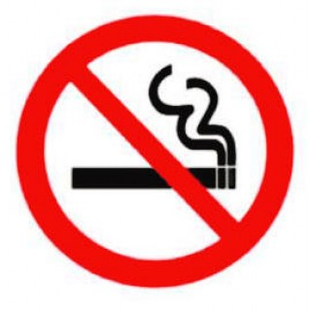Nicotine is the cancer causing chemical in cigarettes.

* Experimental Group
* Control Group
* Comparison

1. Astrology is reliable for predicting the future.

* Experimental Group
* Control Group
* Comparison

1. 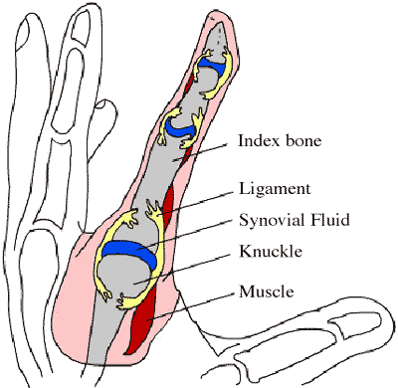Popping your knuckles causes arthritis

* Experimental Group

* Control Group

* Comparison

1. Organic vegetables are healthier than non-organic vegetables

* Experimental Group

* Control Group

* Comparison

f) Acupuncture is an effective treatment for pain relief

* Experimental Group
* Control Group
* Comparison



**Importance of Understanding the Scientific Method**

1. Why are the following critical to the validity of any study?

* Sample size

* Control group

* Reproducibility. (Is the study reproducible?)

9. Assume that a Harvard University study shows that 9 out of 10 people that do not wear jackets in the winter catch the flu. Therefore, wearing a jacket prevents the flu. Considering **ONLY** the data given, would you agree or disagree with the claim of this study? Explain

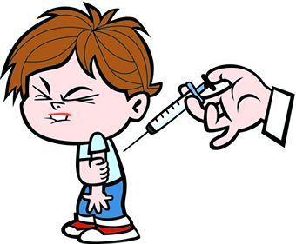10. A 1998 study published in the British medical journal, *The Lancet*, claimed that child   
vaccinations caused various intestinal problems and autism ([*Ileal-lymphoid-nodular hyperplasia,  
 non-specific colitis, and pervasive developmental disorder in children*](http://www.thelancet.com/journals/lancet/article/PIIS0140-6736(10)60175-4/abstract)). This study was eventually   
‘Retracted’. What does it mean when a study is ‘Retracted’?

11. How has the initial study (prior to the ‘Retraction’) influenced parental beliefs with regard to childhood vaccinations?