Name __________________


Buena Vista Natural History Museum
Webpage: http://www.sharktoothhill.org/
(Developed by Zannie Dallara 9-7-2016)

ABOUT Buena Vista: The Purpose of the Buena Vista Museum is to promote the scientific and educational aspects of our earth’s history, particularly paleontology, geology, anthropology, archeology and biology. The museum promotes public education by preserving and displaying the natural history of our area, public education, research, and by serving as a repository of fossils, and other natural history items.

Location: 2018 Chester Ave. Bakersfield, CA 93301

African Exhibit: The preserved group of animals on display are primarily preserved through taxidermy and represent a portion of the large variety of herbivore and carnivores present in Africa.

- Ungulates are animals with hooves. What do hooves have in common with fingernails? Why are they an adaptation to an African environment?

- How are the feet of the mountain goat modified to fit their environment?

- Horns: In many species, horns are primarily found in the males and rarely in females. Why would horns be found primarily in male antelope?

- Giraffe have don’t have horns. What structure do they have and what is the purpose of this structure?

- Cape buffalo are known as one of the fiercest herbivores – why is that? When in doubt watch this video: https://www.youtube.com/watch?v=LU8DDYz68kM

- Carnivores live in Africa too, the Lion, often called the king of the beasts. What hunting strategy to these animals use?

- List and explain 3 other adaptations they have helped lions be successful predators:
Adaptatation1: | Adaptatation2: | Adaptatation3:
Horse Evolution Exhibit: Horses have been changing and adapting to their environment for millions of years.
- When was the Hyracotherium era (the Dawn of Horses) and what was has changed about the overall structure, shape and size of a horse in this time?

- What advantage do these changes offer current living horses?

- What advantages did ancient horses have that current horses do not have?

California’s Changing Water Exhibit: Around the world climate affects the flow and availability of water.

- Give 2 examples of how the world has changed (geologically, climatically or other) and affected the water in Bakersfield.

The Chumash Exhibit: The Chumash are a group of people native to Kern County. They spoke a variety of languages and mostly lived a hunter gatherer existence.
- Examine the Chumash house. What materials were used to build the house and why do you think those materials were selected?

- What is a “Jerky Rack”? (Why did they need to preserve meat by drying it?)
North America Exhibit: these are all species found around you, some as near as Bakersfield itself! There are several species available for observation in this exhibit.

1. The Black bear is known as an omnivore, what does that mean?

2. What adaptations can you observe in the specimens on display that would help them to be successful omnivores?

DINO!!!! Exhibit: These animals are beyond cool! Though they are now extinct it can be argued that they have many ancestors alive today, including birds and alligators.

- Research these two species:
 | Organism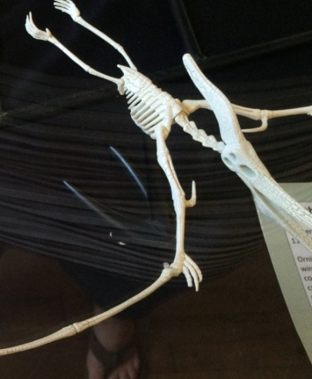 | Organism  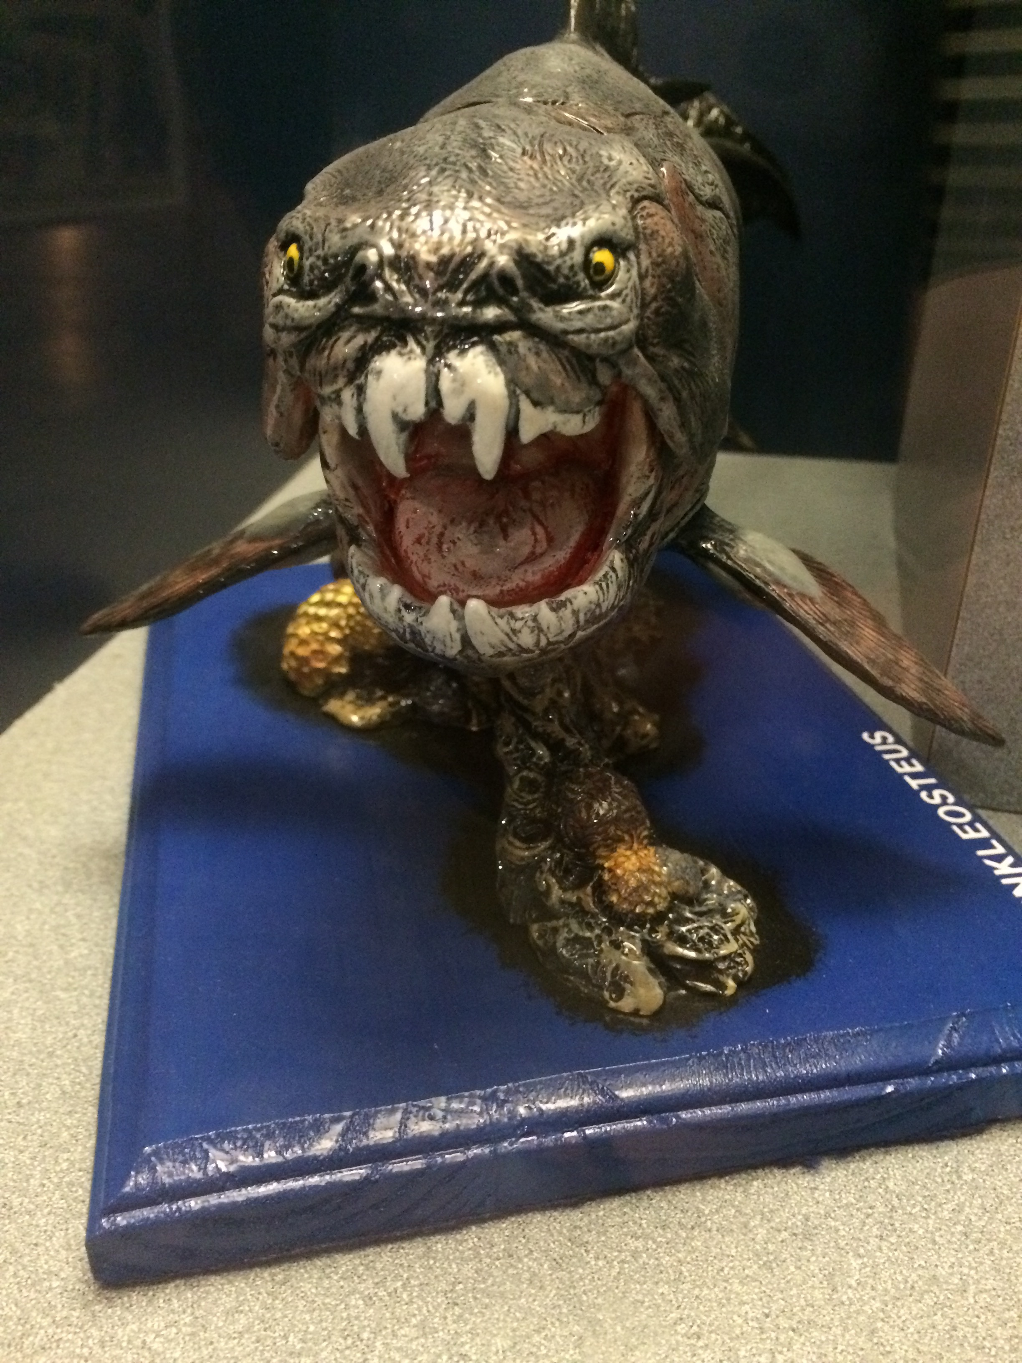
Common name

Scientific name

Habitat
(Environment)
What do they eat?

How long ago did they live
Method of capturing prey

Aquatic Mammals Exhibit: These are animals that have live birth, nurse their offspring, have hair and have mammary glands.
- What evidence is there that whales used to live on land? – Provide 2 pieces of evidence.

- What about the sea lion skeleton surprised you?

- There is an ancient hippo-like critter that is now extinct. Why can we find fossils of aquatic mammals at Shark Tooth Hill?

- In what ways were these animals different than present day hippos?

Final Thoughts:
- Name 2 animals (present or extinct) that have been found at Shark Tooth Hill that you never thought could have ever lived in Kern County.

- What was the most interesting thing you learned at Buena Vista Natural History Museum?

